**TERRAFORM**

**AWS – cloud formation**

**AZURE – arm template**

**GOOGLE CLOUD – deployment manager**

**But terraform do infrastructure automation on all**

**Terraform uses hasicorp configure lang (hcl)**

**IAC – manage and provisioning infra through code instead of through manual confi.**

**Imperatative – we need to define systematic way of code sequence.**

**Declarative – we just need to define desired state,iac will configure for you.**

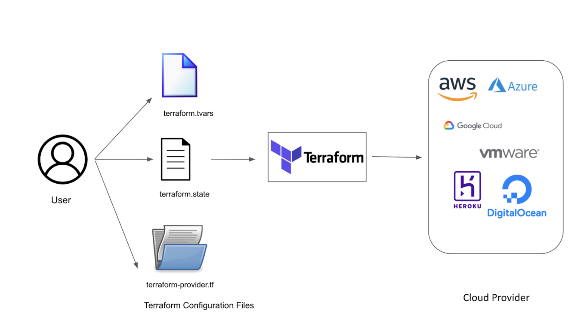

**Providers : aws,azure,googe cloud**

**Terraform init : to initialize working directory**

**Terraform validate : whether configuration is syntactically correct**

**Terraform plan : to create execution environment plan,show what changes occur after apply but don’t do it actually.**

**Terraform apply : used to apply changes required to reach desired state.**

**Terraform destroy : it destroy terraform managed infrastructure.**

**TERRAFORM COMMANDS**

**HCL SYNTAX :**

**Blocks : it group expressions,arguments into a labelled structure,which external blocks can acess it.**

**Arguments : logical expressions in key-value pair.**

**Expressions : it either represent comput values such as string or numeric value.**

**<block type> “<block label>””<block label name>” {**

**<identifier> = <expression>**

**}**

**For giving aws provider access,store it in main.tf file**

**terraform {**

**required_providers {**

**aws = {**

**source = "hashicorp/aws"**

**version = "~> 4.0"**

**}**

**}**

**}**

**Run “Terraform init”**

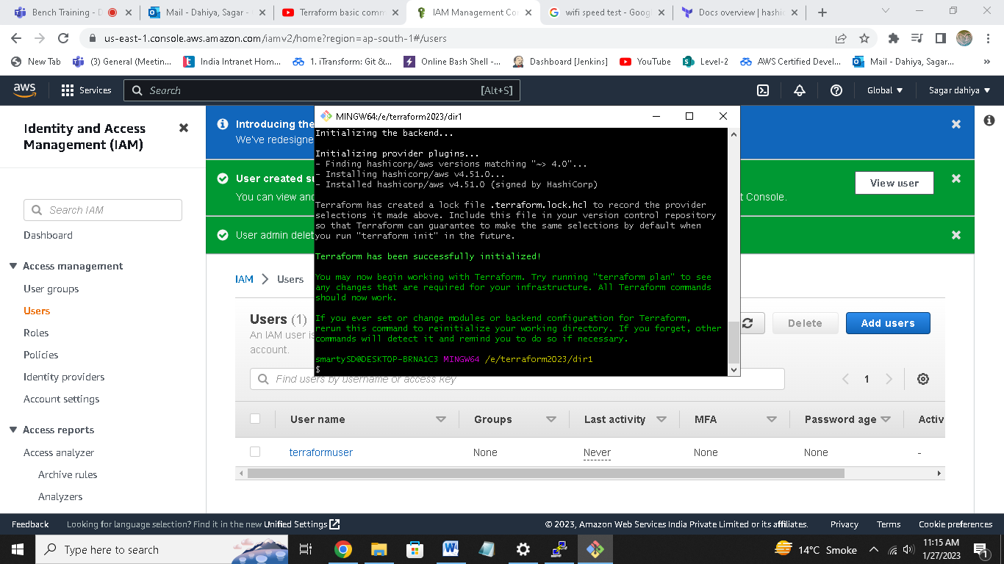

**CONNECT AWS TO TERRAFORM  
  
create new user in aws iam.**

**Give it administrator access**

**Save key pair value.**

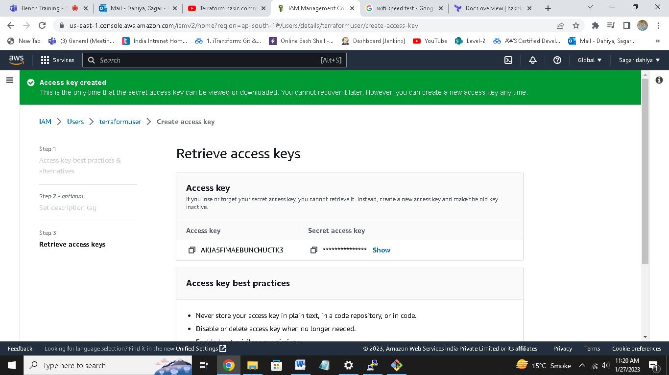

**provider "aws" {**

**region = "us-west-2"**

**access_key = "my-access-key"**

**secret_key = "my-secret-key"**

**}**

**Store it in main.tf file**

**####to make new aws instance**

**resource "aws_instance" "s1" {**

**ami = "ami-06984ea821ac0a879"**

**instance_type = "t2.micro"**

**tags = {**

**Name = "server1"**

**}**

**}**

**Store it in main.tf**

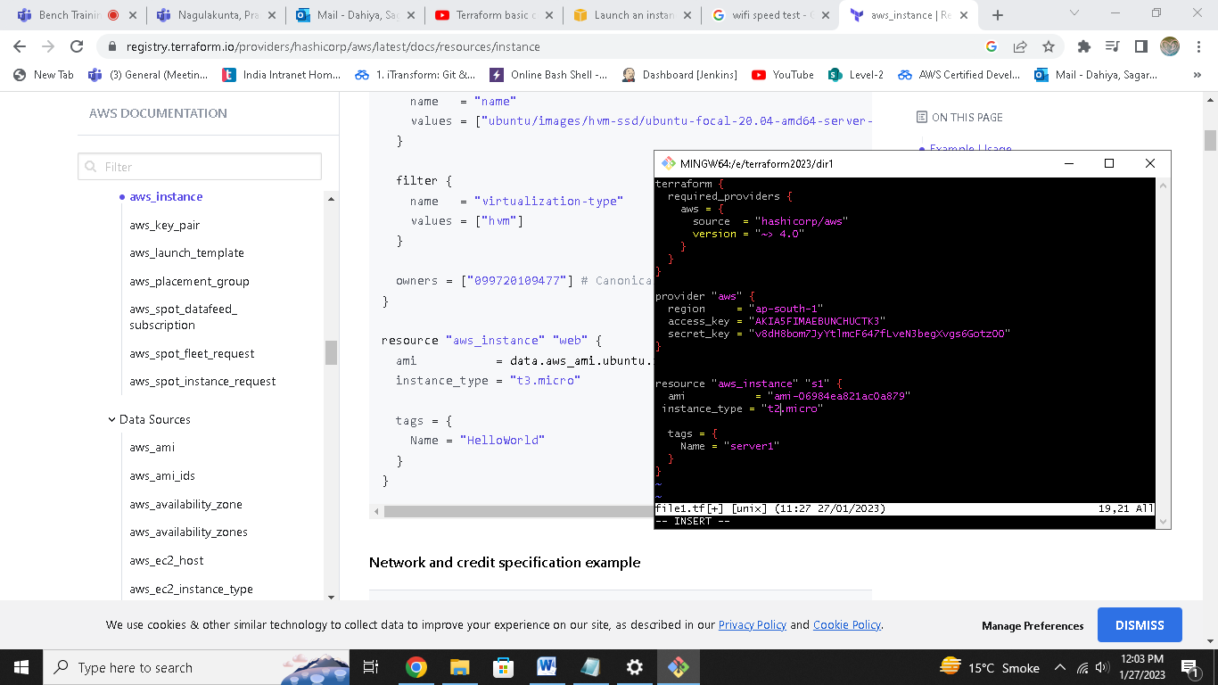

**Terraform validate**

**# to check syntax is correct or not**

**Terraform plan**

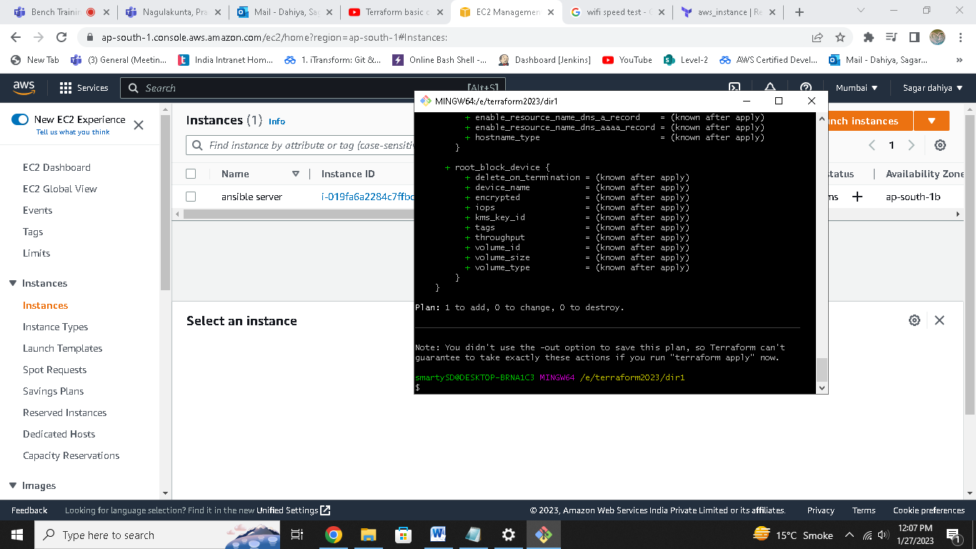

**Currently there is only 1 instance running.**

**Now run**

**Terraform apply**

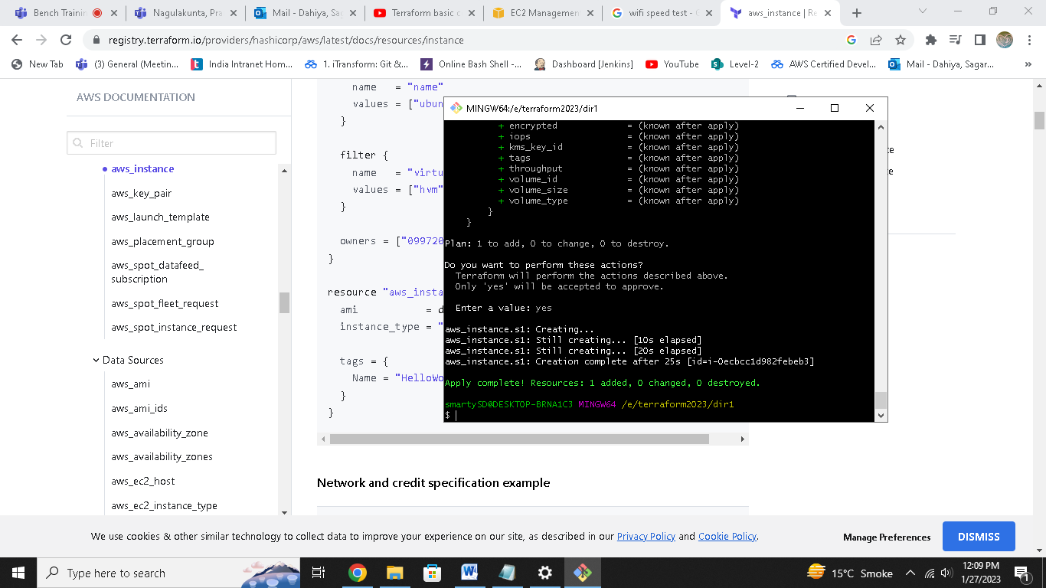

**Now check aws instances**

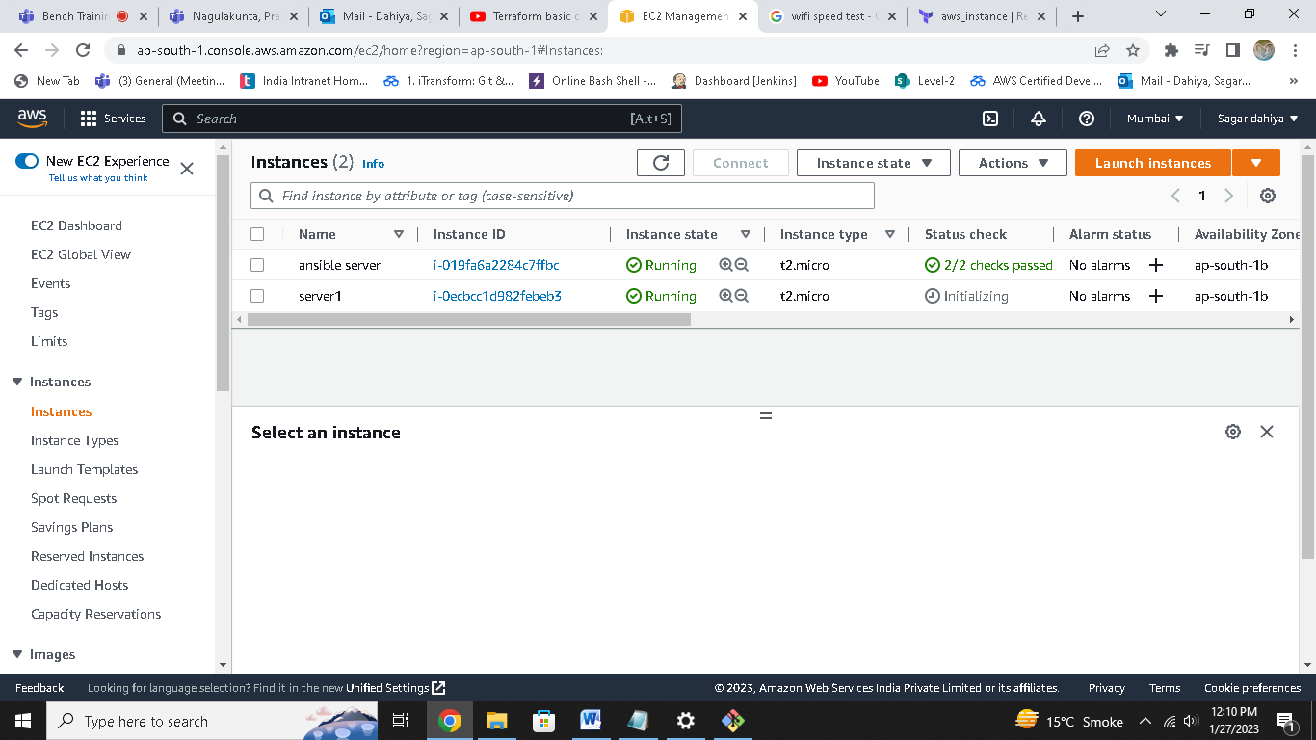

**You can see our server1 is running now.**

**Now to delete it,run**

**Terraform destroy**

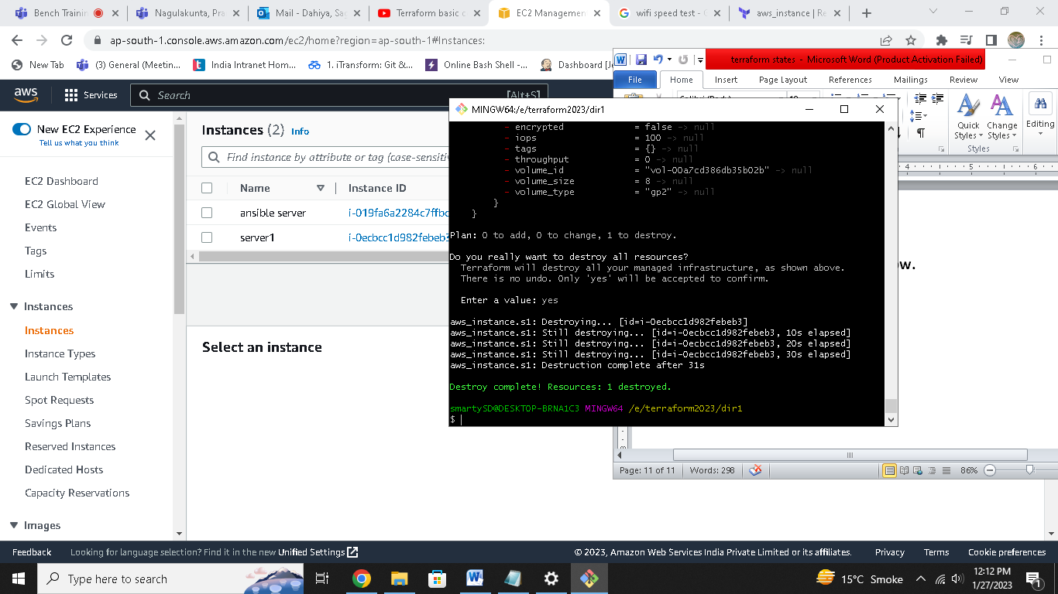

**Our server destroyed**

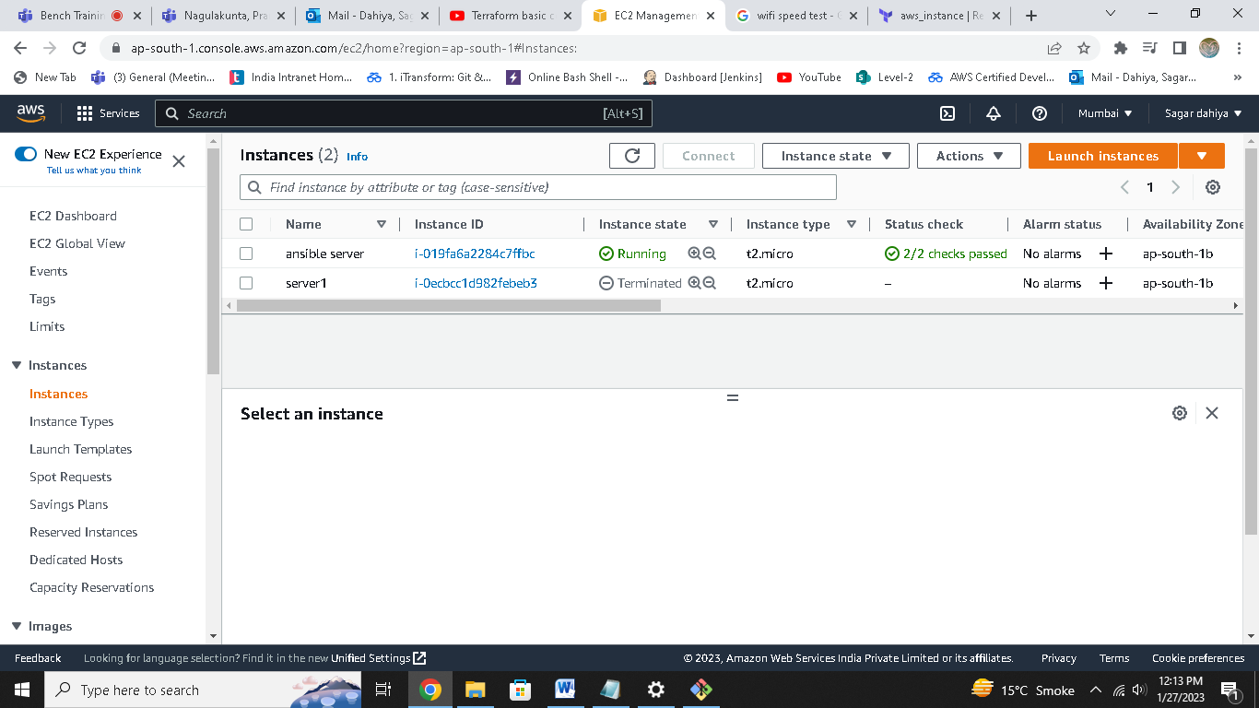

**If you want to create 3 server at once**

resource "aws_instance" "s1" {

ami = "ami-06984ea821ac0a879"

instance_type = "t2.micro"

tags = {

Name = "server1"

}

}

**Copy paste it 3 times**

**Now again terraform apply**

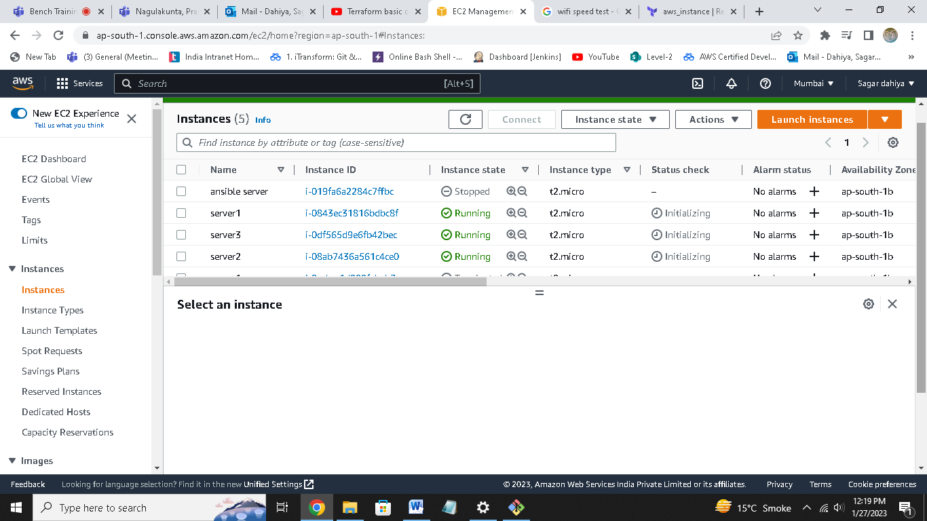

**3 servers are running.**